Procedures for Encoding Finding Aids
with the Virginia Heritage Clip Library for NoteTab
December 2014

Keep track of your unique eadids! Some kind of tracking database or spreadsheet is recommended. If you have more than one person doing encoding it is particularly important.

Encode finding aid by following clips in sequential order.

VH Clip Library Item 1: <eadheader> and <frontmatter> (fields marked with * are required)

- Enter eadid number (your unique institutional code is provided)*

- Select finding aid status: This attribute indicates how complete the finding aid is. Most VIVA participants use “edited-partial-draft”

- Complete <titleproper> Be sure to use DACS compliant titles! The clip will provide the first part of the title such as “A Guide to the” or “An Inventory of”*

- Enter date(s)*

- Enter sort title. Be sure to include comma to set off title of collection. (examples below)*

McCaw, James Brown, papers, (dates optional)
Tredegar Iron Works, records
Dabney-Jackson collection
University of Virginia, Office of the President

- Enter accession number/manuscript without label

- Enter author of finding aid* (not the name of the person encoding a legacy guide)

- Enter person encoding finding aid

- Enter date—be sure to use a consistent format

- Enter processor of collection

- Select source from which EAD is derived*

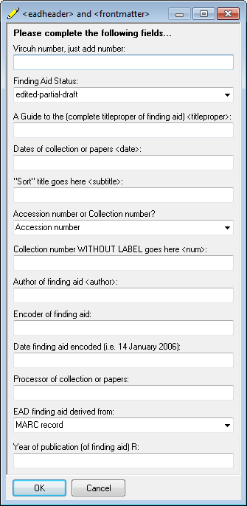

A separate clip is available for revisions to existing ead finding aids. Use the <revisiondesc> element in the <eadheader> to encode information on a guide that is substantial edited, altered or updated. Be sure to position your cursor after the closing </profiledesc> tag.

The clip automatically adds the tags for language of the finding aid. All finding aids are assumed to be written in English. If this is not the case, you can manually add another language.

VH Clip Library Item 2: Descriptive Summary (upper level <did>)

- Select type of date

- Select location from menu, if needed. Remember location information displays to the public. This is a good tag to use when a collection is stored off-site.

- Select label <physdesc>*

- Enter physical description of collection (size, extent, format, etc.) This description must begin with an integer such as 5 document cases, 2 linear feet. 0.5 cubic feet etc.*

- The clip automatically assigned the English <langmaterial> tag. If you have materials in the collection in other languages you will need to manually enter code with proper ISO for the language.

- Enter abstract if available. This is not required element

- Enter creator <origination> This element is not currently required but will aid in generating MARC records

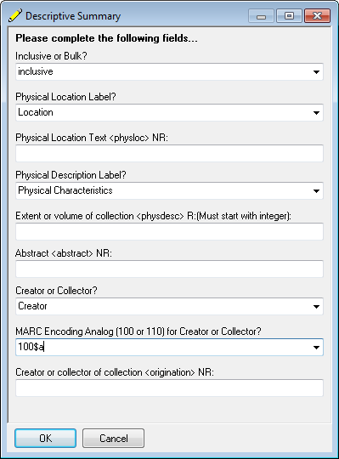

VH Clip Library Item 3: Required Administrative Data <descgrp> (former section 2 of the Mu forms)

- Enter access restrictions or use default language*

- Enter use restrictions or use default language*

- Preferred citation is supplied with name of collection, collection number, and repository. Add anything else you wish to appear in this element*

- Enter acquisition information for <acqinfo>*

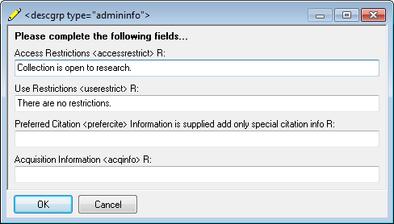

VH Clip Library Item 3A: Optional Administrative Information <descgrp>

Skip to item 4 in clip library if you have no optional administrative information. If you are returning to this portion of your EAD document, be sure you insert this information following the closing tag for acquisition information </acqinfo> This is the only place where this information can be insert and have your document parse.

- Enter text for alternative format <altformavail>

- Enter text for accruals <accruals>

- Enter text for appraisal <appraisal> Remember that this information is displayed to the public

- Enter custodial history if applicable <custodhist>

- Enter processing information <processinfo>

VH Clip Library Item 4: Close Administrative Information </descgrp>
- Click on tag to add a closing </descgrp>

VH Clip Library Item 5: Biography/Scope and Content/Arrangement Select header for <bioghist> or use default

- Enter information for <bioghist> You can copy from an existing finding aid right into the text box. If you need additional paragraphs. Move cursor between the closed paragraph </p> and inside the closing </bioghist> tags. Click on paragraph format tags (under item 5c). Paste or type additional text between tags. Repeat as necessary. When you finish the <bioghist> move the cursor to outside the closing </bioghist>

- Enter information for <scopecontent> You can copy from an existing finding aid right into the text box. If you need additional paragraphs. Move cursor between the closed paragraph </p> and inside the closing </scopecontent > tags. Click on paragraph format tags (under item 5c). Paste or type additional text between tags. Repeat as necessary. When you finish the <scopecontent> move the cursor to outside the closing </scopecontent>

- Enter information for <arrangement> You can copy from an existing finding aid right into the text box. If you need additional paragraphs. Move cursor between the closed paragraph </p> and inside the closing </arrangement> tags. Click on paragraph format tags (under item 5c). Paste or type additional text between tags. Repeat as necessary. When you finish the <arrangement> move the cursor to outside the closing </arrangement>

VH Clip Library Item 6: Adjunct Descriptive Data <descgrp>

This section is for other descriptive elements such as separated materials, related materials, other finding aids, bibliographies and indexes

- Click on first clip under item 6

- Click on element entry clip. Select appropriate tag from menu

- Elements must appear in the order they are listed in the menu or the document will not parse

- For <bibliography> additional citations can be added using the <bibref> tag. Formatting tags from the clip can be used for quotes and italics etc.

- Click on tag to close </descgrp>

VH Clip Library Item 6A

- If you want to create an index within the finding aid use this clip. It must follow the order prescribed in the Best Practice Guidelines between <fileplan> and <originalsloc>

VH Clip Library Item 7: Controlled Access <controlaccess>

- Click on first clip under item 7

- Click on item tags entry clip for additional controlled access entries. When you complete your last entry, be sure to move your cursor below the last closed </list> and closed </controlaccess>

If you need an <odd> element you should manually add it following <controllaccess>

VH Clip Library Item 8: Close </archdesc> and </ead>

- Click on clip to close your ead finding aid.

- Click on Clean Up to eliminate empty tags and characters that will not parse.

- Parse finding aid to see if there are errors in the upper portion (use eadtest for this)

- Correct errors until the document parses

- If you are adding a container list <dsc>, manually delete the closing </archdesc> and </ead> tags. You will add these tags back in after you mark up the container list

VH Clip Library Item 8: Description of Subordinates Components <dsc> Contents List

Use the Virginia Heritage Best Practice Guideline to govern your encoding of contents lists.

- Click on item 8A to open <dsc>

- Select type of description—see Virginia Heritage Best Practice Guidelines and Tag Library for definitions

- Click on <c01> tag fill in fields as appropriate. Any empty fields will be removed during clean up process

- Elements within a <c> tag must be encoded in the order shown in the clip. If you add any tags manually you must follow the prescribed order or your document will not parse. See Best Practice Guidelines

- Add <c02>,<c03> etc. Remember that all <c02>s are included in <c01>, and <c03>s are included in <c02>s etc.

- When finished encoding the contents list, click on finish </dsc>. This closes </archdesc> and </ead>

- Put your cursor at the end of the document

- Click on clean-up <dsc> clip

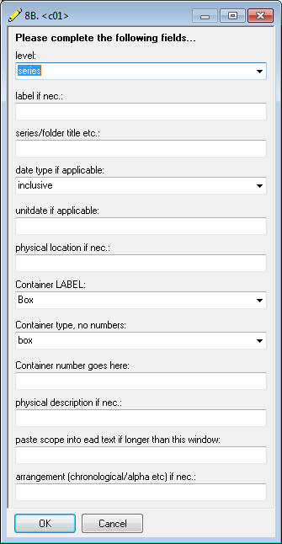

You may delete a published file by writing over it with a file of the same eadid. To delete other files, contact Steven Majewski at sdm7g@eservices.virginia.edu

